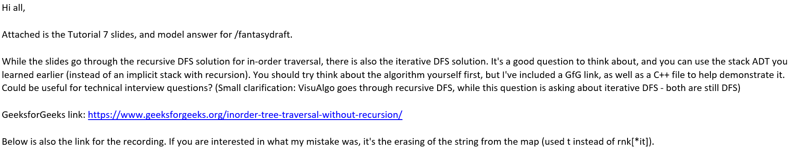

GeeksforGeeks link: <https://www.geeksforgeeks.org/inorder-tree-traversal-without-recursion/>